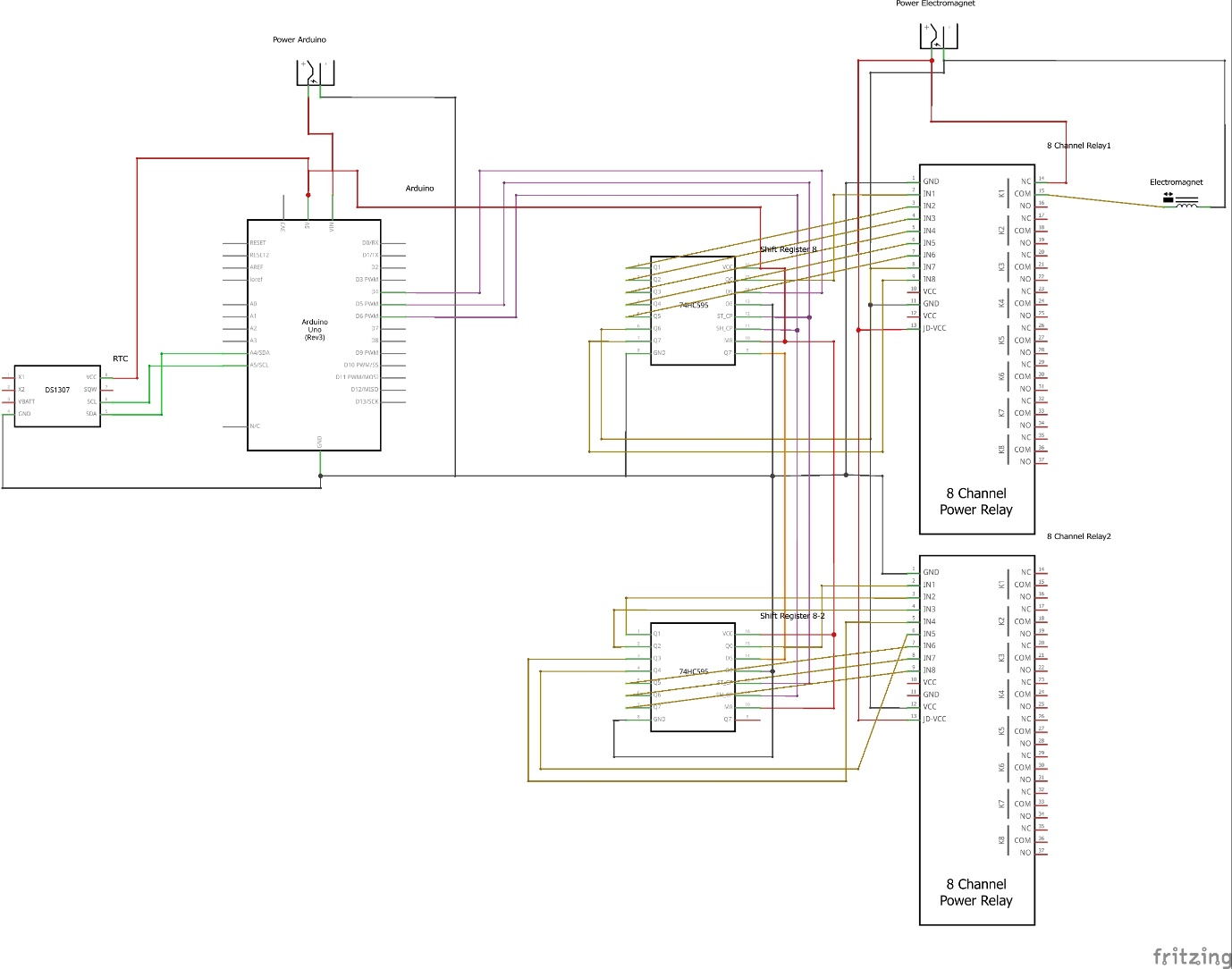

Parts required:

1x DS1307 (RTC module)

1x Arduino Uno

2x Power source

2x 74HC595 Shift register

2x 8 Channel Power Relay OR 1x 16 Channel Power Relay

16x 12v electromagnet